**EVs Charging Technology**

An electric charging station cannot be seen as just an element in an infrastructure that supplies electric energy for the recharging of electric vehicles by simply transforming electricity from AC to DC voltage. Conventional perception of charging station is rapidly advancing with technological innovations on electric grid and EVs battery technology. EVs are becoming smart cars with Internet of Things (IoT) and electric grids becoming smart grids. EVs charging stations are also becoming a significant elements that enable communication between these two advanced product and service environments that evolves beyond our imagination and too fast.

**Context**

Charging stations fall into 4 basic context as residential charging that is the most common charging method, charging while parked that is a commercial venture charged or free, offered in partnership with the owners of the parking lot, fast charging that supplies higher than 40 kW, delivering over 60miles (100 km) of range in 10–30 minutes and battery swaps that enable to change battery under 15 minutes. There are four different modes of charging defined by the International Electrotechnical Commission (IEC 62196). Plug types can also grouped in four types.

**Charging times and fast Charging**

Charging time is dependent on reachable phase of electric grid and battery capacity of the EVs. Yet new technological innovations comes out very quickly and provides shorter times. At present, different EVs are on the market that provide different battery capacity about 20kWh (Nissan) or 85 kWh (Tesla Motors).

DC fast chargers – also called hyper charger– has scale from 250 KW to 1MW and those has the highest energy density in its class. Fast chargers are designed to provide fleets of any sizes, in general mass transit vehicles. This makes DC fast chargers more efficient and practical for governments and companies.

|  |  |  |  |
| --- | --- | --- | --- |
| **Charging time for 100 km** | **Power supply** | **Voltage** | **Max current** |
| **6–8 hours** | Single phase - 3.3 kW | 230 VAC | 16 A |
| **3–4 hours** | [Single phase - 7 kW](http://en.wikipedia.org/wiki/Single_phase) | 230 VAC | 32 A |
| **2–3 hours** | [Three phase - 10 kW](http://en.wikipedia.org/wiki/Three_phase) | 400 VAC | 16 A |
| **1–2 hours** | [Three phase - 22 kW](http://en.wikipedia.org/wiki/Three_phase) | 400 VAC | 32 A |
| **20–30 minutes** | [Three phase - 43 kW](http://en.wikipedia.org/wiki/Three_phase) | 400 VAC | 63 A |
| **20–30 minutes** | [Direct current - 50 kW](http://en.wikipedia.org/wiki/Direct_current) | 400 - 500 VDC | 100 - 125 A |
| **10 minutes** | [Direct current - 120 kW](http://en.wikipedia.org/wiki/Direct_current) | 300 - 500 VDC | 300 - 350 A |

**Battery swapping**

For this technology first the EV must be designed for "easy swap" of batteries such as Better Place, Tesla Motors, and Mitsubishi Heavy Industries. Some companies use different battery switching technology to extent EVs driving range. The driver does not own the battery in the car, transferring costs over the battery, battery life, maintenance, capital cost, quality, technology, and warranty to the battery switch station company. Moreover, for battery swapping system, ownership of the battery belongs to company of swapping station and this enables decrease in cost of EVs manufacturing up to %45. Swapping stations also give hope to establish more advanced connection with smart grid system and being partner of more sustainable energy system in a profitable case. However, electric vehicle manufacturers that are working on battery switch technology have not standardized on battery access, attachment, dimension, location, or type.

<http://www.andromedapower.com/>

<http://www.evtronic.com/page7/page9/index.html>

<http://www.eaton.com/Eaton/ProductsServices/Electrical/Markets/AlternativeEnergy/ElectricVehicle/index.htm?wtredirect=www.eaton.com/plugin#tabs-2>

**Electric vehicle hyper charger**

<http://www.eesi.org/briefings/view/16th-annual-congressional-renewable-energy-and-energy-efficiency-expo-forum?/expo2013>

**Smart grid communication**

Recharging a large battery pack presents a high load on the electrical grid, but this can be scheduled for periods of reduced load or reduced electricity costs. In order to schedule the recharging, either the charging station or the vehicle can communicate with the [smart grid](http://en.wikipedia.org/wiki/Smart_grid). Some plug-in vehicles allow the vehicle operator to control recharging through a web interface or smartphone app. Furthermore, in a [Vehicle-to-grid](http://en.wikipedia.org/wiki/Vehicle-to-grid) scenario the vehicle battery can supply energy to the grid at periods of peak demand.

<http://www.plugincars.com/tesla-motors-introduces-free-app-model-s-sedan-126356.html>

**Wireless Power Transfer**

Wireless charging systems following the principle of inductive resonant energy transfer can achieve the best energy transfer rates and efficiency rates with increased coil distances, reduced electromagnetic inference risks and more compact geometrical dimensions in the (lower) kHz frequency band.

 It is important to keep the geometrical alignment of primary and secondary within certain tolerance values in order to ensure a sufficient efficiency rate of the energy transfer.

With quasi-dynamic wireless charging the energy is transferred from the road-side primary coil system of limited length to the secondary coil of a slowly moving or in stop-and-go mode moving vehicle (with passengers).

With dynamic wireless charging (see fig. 3) the energy is transferred via a special driving lane equipped with a primary coil system at a high power level to a secondary coil of a vehicle moving with medium to high velocity.

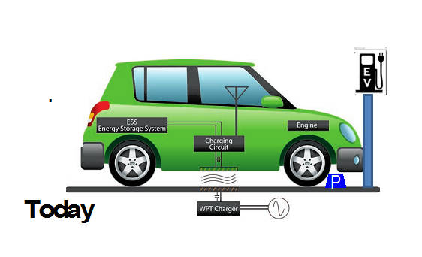

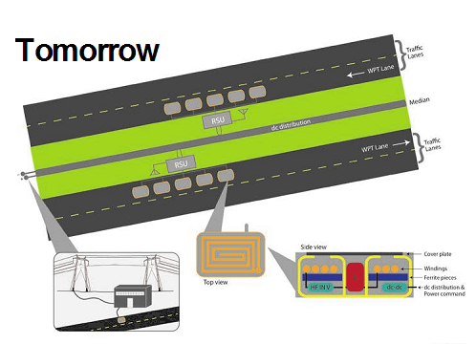[**http://electricvehicle.ieee.org/2014/06/26/overview-wireless-charging-electrified-vehicles-basic-principles-challenges/**](http://electricvehicle.ieee.org/2014/06/26/overview-wireless-charging-electrified-vehicles-basic-principles-challenges/)

<https://www.youtube.com/watch?v=Gw6XtzEOlyI> (Wifi, active caharging)

<https://www.youtube.com/watch?v=h6jKvZgkSFE>

**EV Battery Technology**

With suitable power supplies, good battery lifespan is usually achieved at rates not exceeding "0.5*C*" or so, taking two to three hours for a full charge, but faster charging can be done.

Charging time is often limited by the capacity of the [grid](http://en.wikipedia.org/wiki/Electrical_grid) connection. A normal [household](http://en.wikipedia.org/wiki/Household) [outlet](http://en.wikipedia.org/wiki/Electrical_outlet) delivers 1.5 [kilowatts](http://en.wikipedia.org/wiki/Kilowatt) (in the US, Canada, Japan, and other countries with 110 [volt](http://en.wikipedia.org/wiki/Volt) supply) and 3 kilowatts (in countries with 240 V supply).

Many European countriesfeed domestic consumers with a 3 phase system fused at 16-25 amp allowing for a theoretical capacity around 11-17 kW. At this higher power level charging even a small, 7 kilowatt-hour (14–28 mi) pack, would require less than an hour. This is slow compared to the effective power delivery rate of an average petrol [pump](http://en.wikipedia.org/wiki/Pump), about 5,000 kilowatts. Ultimately, even if the supply power is increased, batteries cannot accept charge at greater than their maximum charge rate (usually "2*C*" or "3*C*"), giving a recharge time of 20 to 30 minutes to 80%, with slower charging usually recommended for the remaining 20%.

In 2005, [handheld](http://en.wikipedia.org/wiki/Handheld) device battery designs by [Toshiba](http://en.wikipedia.org/wiki/Toshiba) were claimed to be able to accept an 80% charge in as little as 60 seconds. Scaling this [specific power](http://en.wikipedia.org/wiki/Power_density) characteristic up to the same 7 kilowatt-hour EV pack would result in the need for a peak of 340 kilowatts of power from some source for those 60 seconds. It is not clear that such batteries will work directly in BEVs as heat build-up may make them unsafe.

Many BEV drivers prefer refueling at home, avoiding the inconvenience of visiting a [fuel station](http://en.wikipedia.org/wiki/Fuel_station). Some workplaces provide special parking bays for electric vehicles with charging equipment provided.

**Battery Cost Estimate Comparison**

**Battery Longevity Estimate Comparison**

<http://www.eenews.net/stories/1059984950>